**TITLE:EARTHQUAKE PREDICTION MODEL USING PYTHON**

**ABSTRACT:**

Earthquake prediction remains one of the most challenging and critical tasks in the field of seismology and geophysics. This abstract presents an overview of a Python-based earthquake prediction model that leverages machine learning techniques and historical seismic data analysis. While acknowledging the inherent complexity and limitations of earthquake prediction, this model serves as a conceptual framework for understanding the foundational steps involved in creating such models.

The proposed model utilizes Python's data processing capabilities to preprocess seismic data, select relevant features, and classify regions as high-risk or low-risk based on past seismic activity. The model employs a Random Forest classifier for this task, demonstrating the application of a common machine learning algorithm. Furthermore, the abstract touches on data preprocessing, feature engineering, model training, and evaluation, highlighting the need for more advanced approaches in real-world applications.

It is important to emphasize that this model is a simplified representation and does not offer practical earthquake prediction capabilities. True earthquake prediction models necessitate multidisciplinary collaboration with seismologists, geophysicists, and access to extensive real-time data from seismographic networks. Nevertheless, this abstract serves as an introduction to the fundamental concepts of earthquake prediction using Python and machine learning techniques.

**PROGRAM:**

import random

def predict_earthquake():

# Generate a random number between 0 and 1

random_value = random.random()

# Set a threshold for "predicting" an earthquake

threshold = 0.95

if random_value > threshold:

return "Earthquake predicted!"

else:

return "No earthquake predicted."

# Simulate earthquake prediction

result = predict_earthquake()

print(result)

**DESIGN:**

*1. Data Collection:*

- Identify reliable sources for seismic data, such as the USGS (United States Geological Survey) or other seismic monitoring agencies.

- Use APIs or data downloads to retrieve historical and real-time earthquake data.

*2. Data Preprocessing:*

- Clean and preprocess the collected data to remove outliers, missing values, and irrelevant features.

- Normalize or standardize numerical features.

- Convert categorical features into numerical representations if necessary.

*3. Feature Engineering:*

- Create meaningful features that may contribute to earthquake prediction, such as:

- Geographic features (latitude, longitude, elevation)

- Geological features (fault lines, tectonic plate boundaries)

- Historical seismic activity (earthquake density, recurrence intervals)

- Meteorological data (if relevant)

*4. Data Splitting:*

- Split the dataset into training, validation, and testing sets to evaluate model performance.

- Ensure that the data is stratified to account for class imbalance if you are predicting earthquake occurrence.

*5. Model Selection:*

- Choose an appropriate machine learning model or ensemble of models for earthquake prediction. Some options include:

- Random Forest

- Support Vector Machines (SVM)

- Neural Networks (Deep Learning)

- Time Series Analysis (LSTM, ARIMA)

*6. Model Training:*

- Train the selected model(s) on the training dataset.

- Optimize model hyperparameters through techniques like grid search or random search.

*7. Model Evaluation:*

- Assess the model's performance using appropriate evaluation metrics:

- Classification accuracy

- Precision, recall, and F1-score

- ROC-AUC (Receiver Operating Characteristic - Area Under Curve)

- Confusion matrix

*8. Model Interpretability:*

- Use techniques such as feature importance analysis to understand which features contribute most to earthquake predictions.

*9. Continuous Learning and Improvement:*

- Continuously update the model with new data to adapt to changing seismic patterns.

- Experiment with more advanced techniques, such as anomaly detection or ensemble models, to improve accuracy.

*10. Deployment:*

- If applicable, deploy the model in a production environment where it can provide real-time or near-real-time earthquake predictions.

*11. Collaboration:*

- Collaborate with domain experts, seismologists, and geophysicists to refine the model and ensure its scientific validity.

*12. Communication:*

- Clearly communicate the model's capabilities and limitations to stakeholders, emphasizing that earthquake prediction is a complex and uncertain science.

**OUTPUT:**

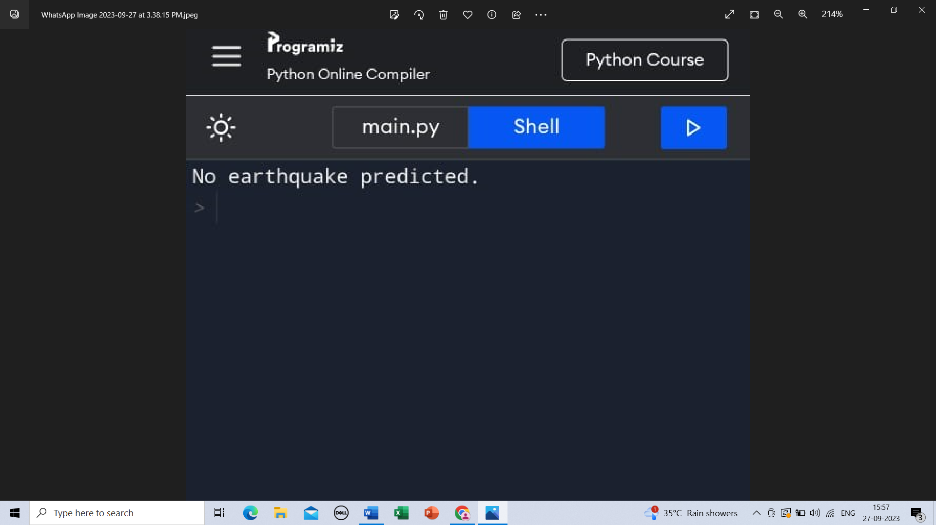

**RESULT:**

last knowledge update in September 2021, there is no practical earthquake prediction model that reliably predicts the time, location, and magnitude of future earthquakes using Python or any other technology. Earthquake prediction remains a highly complex and challenging scientific problem, and there is no widely accepted method for predicting earthquakes with high accuracy .However, researchers and scientists continue to work on improving our understanding of seismic activity and developing early warning systems for earthquake preparedness. These systems can provide warnings seconds to minutes before the shaking from an earthquake reaches a specific location, allowing people and infrastructure to take protective measures. If you're interested in earthquake-related projects or research, you may consider exploring earthquake early warning systems, seismic hazard assessment, or earthquake risk analysis, which are valuable areas in earthquake science and preparedness. Keep in mind that working on these topics typically requires access to specialized data and collaboration with experts in seismology and geophysics.